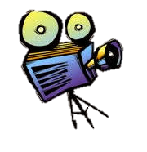
Book Trailer Project

Name:

Name of Book:

Opening Line (you may want to pose this as a question):

1.

At least 7 other lines (make sure to tell the audience the book name and author some where):

2.

3.

4.

5.

6.

7.

You need at least 6 total pictures. One of them being the picture of the book. Save these pictures to a folder in your “Pictures” folder on your computer.

